LAB 3 - Objective-C Collections, File I/O, and Table Views

Objectives
- Understand and use the Objective-C collection types NSArray and NSDictionary
- Use the Cocoa Touch framework to access the file system
- Construct a list of data with the UITableView class and the Delegate design pattern
- Use the Instruments tool to detect memory leaks in a program

Tasks

Task 1 - Working with the Filesystem

Any iOS application exists inside of a sandbox. This means that iOS will not let the application access any other application on the device. There are some directories, however, that are within the sandbox - temp directories, as well as all the files in your project!
- Create a new application using the View-based Application template. Put a single UILabel on the screen and 2 buttons - “Ascending” and “Descending”.
- Hook up the buttons and the label so that when the application is loaded, the contents of the file actors_list.txt is loaded into the label. When the “Ascending” button is pressed, the names should sort in alphabetical order. When the “Descending” button is pressed, the names should appear in reverse alphabetical order. Take a screenshot in each state.

Hint: NSFileManager *mgr = [NSFileManager defaultManager]; will
return the instance of the system’s file manager. Look at the API reference to find out
how to get the contents of a file.

Task 2 - It’s All Data To Me

The NSDictionary object is a collection object based on key-value pairs. This construct is also called a hash. NSDictionary objects can hold any NSObject subclass as a value, including other NSDictionary objects.

Both NSArray and NSDictionary also have convenient helper methods that allow developers to quickly read and write the contents of a collection to disk as XML. These XML files are called property lists, or more often “plists”.
- Create an app that loads the data in the property list file configuration.plist into an NSDictionary object. Once in memory, change all of the strings in the dictionary to lowercase, and then write the new dictionary to lowercase_configuration.plist in your app’s Documents/ subdirectory.
- Open the lowercase_configuration.plist file, take a screenshot to show that all of the strings at all levels are in lowercase.

Task 3 - Line Up The Usual Suspects
Mobile applications often use scrollable tables of data to create hierarchies and lists. In UIKit, the class to use is a UITableView, which is a UIView subclass.

- Create an application that displays a list of actors’ names, input from the provided file actors_list.txt. The display should be sorted in alphabetical order by last name.
- When the device is in landscape orientation, the table should sort in reverse (Z-A).

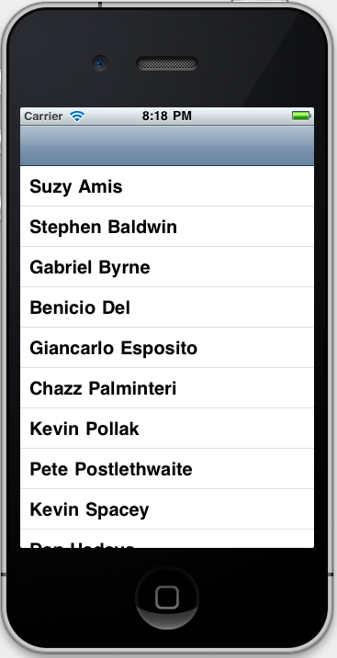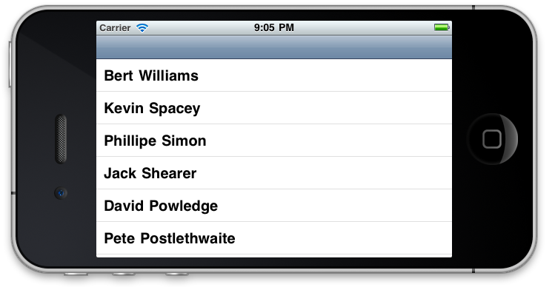
Task 4 - Retain This

Xcode also contains a tool called Instruments with various tools to help you assess your code’s health. You can view overall CPU usage, memory usage, or automatically detect memory leaks when they happen.
- Run your Task 1 application using the Leaks instrument. Select Product > Profile and choose Leaks. Run your program for 1 minute, scrolling up and down the list many times. Take a screenshot showing that your application has no leaks after 1 minute.

Useful References

Apple’s Low-Level File Management Guide - http://developer.apple.com/library/ios/#documentation/Cocoa/Conceptual/LowLevelFileMgmt/Articles/StandardDirectories.html#//apple_ref/doc/uid/20001279-BCIIHBEE

How To Find Your (Simulated) App On the Desktop Hierarchy - http://trailsinthesand.com/where-is-the-iphone-simulator-filesystem-stored/

NSString API -
http://developer.apple.com/library/mac/#documentation/Cocoa/Reference/Foundation/Classes/NSString_Class/Reference/NSString.html

